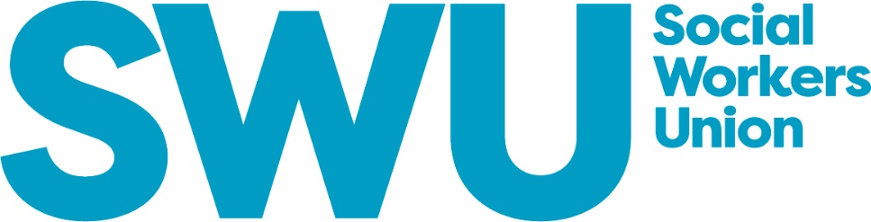

SOCIAL WORKERS UNION
NOMINATION FORM – NATIONAL EXECUTIVE MEMBER
Closing date: 5pm Friday 28th August 2026

Positions Available for term 2026 onwards (to commence 27th November 2026):

• UK Representatives: 3 positions (2-year appointment)
• Scotland Representative: 1 position (2-year appointment)
• Wales Representative: 1 position (2-year appointment)
• England Representative: 1 position (2-year appointment)
• England Representative: 1 position (3-year appointment)
• Northern Ireland Representative: 1 position (3-year appointment)
• Student / NQSW Representative: 1 position (2-year appointment)

DETAILS OF NOMINEE:

I am applying for the following position:

……………………………………………………………………………………………….

FULL NAME
MEMBERSHIP NUMBER
ADDRESS
EMAIL ADDRESS
TELEPHONE NUMBER

1ST INDIVIDUAL NOMINATION

PROPOSER NAME
EMAIL ADDRESS
MEMBERSHIP NUMBER
E-SIGNATURE

2ND INDIVIDUAL NOMINATION

PROPOSER NAME
EMAIL ADDRESS
MEMBERSHIP NUMBER
E-SIGNATURE

CANDIDATE INFORMATION

Social Work Qualification

Other Professional Qualifications

Have you served (or do you serve) on a committee of any other Association/ organisations / unions? Please give brief details:

Have you ever been sanctioned or removed from the register of a UK social work regulator for reasons of fitness to practice?

Please give a brief history of your professional career | Brief summary below (max 250 words):
Election Statement  Please describe how you meet the skill, knowledge and experience criteria of the role and how you would fulfil the Executive role description.  This will be sent out with the ballot paper (if applications exceed  Executive places offered).  A maximum of 500 words is permitted.  In line with the Trade Union and Labour Relations (Consolidation) Act 1992, the contents of the election address, including spelling and grammar, are the candidate’s responsibility.  SWU will not be responsible for any civil or criminal liability arising from publishing, copying or distributing individual election addresses. This liability will rest with the individual candidate. | Election statement below (max 500 words):
Consent

The data you have supplied will be stored with SWU following the end of the election. Your personal information will not be disclosed to any other organisation other than the SWU.

E-Signed:

Acceptance of Nomination
I hereby signify my acceptance of nomination for the position of National Executive Member of SWU and declare that I am eligible for election.

Signature ………………………………………………. Date ………………………….

Please return the Nomination Form to: joanne.marciano@swu-union.org.uk
Please also complete and return the optional equalities monitoring form below and return
to the same email address.

Candidate Photograph:
You may also submit a recent photograph. This must be a head and shoulders shot of you, either
black and white or colour.

Equalities & Diversity information

SWU is committed to being an inclusive, anti-discriminatory and anti-racist organisation. We strive to ensure all members and employees receive equal treatment regardless of race, colour, ethnicity, nationality, disability, age, gender, sexual orientation or marital status. To assist us in monitoring the operation of our equal opportunities policy within Council election and roles, please answer the following optional questions. (Tick box where appropriate.) This form will be detached from your application and any personal identifying information and data will only be used in aggregate. Your decision to answer these questions or not has no bearing on the process of the election.

GENDER MALE □ FEMALE □ NON-BINARY □PREFER NOT TO SAY □ OTHER□

AGE 16-18 YRS □19-25 YRS □ 26-35 YRS □ 36-45 YRS □ 46-64 YRS □
65 YRS AND OVER □ PREFER NOT TO SAY □

RACE/ETHNICITY

Please make sure that you read all the categories and then tick the box that applies to you.
Asian or Asian British: INDIAN □ PAKISTANI □ BANGLADESHI □ OTHER □
Black or Black British: CARIBBEAN □ AFRICAN □ OTHER□
Chinese or other ethnicity: CHINESE □ OTHER □
Mixed race: WHITE AND ASIAN □ WHITE AND BLACK CARIBBEAN □
WHITE AND BLACK AFRICAN □ ANY OTHER MIXED BACKGROUND □
White: BRITISH □ EUROPEAN □ AUSTRALASIAN □ NORTH AMERICAN □ OTHER □
Prefer not to say: □

DISABILITY Do you consider yourself to have a disability? YES □ NO □

SEXUALITY Do you consider yourself to be:

Gay/lesbian□ Bisexual □ Heterosexual □ Other □Prefer not to say: □

